Returns to Education in the Russian Federation:  
Does Depreciation Explain Some Recent Trends?

Ekaterina Melianova

Suhas Parandekar

Artëm Volgin

This paper explores the topic of depreciation of human capital as a possible explanation for observed trends in the returns to education in the Russian Federation. Estimates of depreciation are presented for various sample groups. Depreciation first decreased and then increased in the period 1994-2018. University educated workers add human capital even after they stop full-time studies; this happens less with vocational graduates.

# Depreciation of Human Capital in the Russian Federation

The first working paper of this series analyzed the trends in the returns to education in the Russian Federation between 1994 and 2018 (Patrinos et al. 2020). The analysis showed how returns climbed and then declined, forming a gently curved inverse-U shape. The figure from that working paper is reproduced in Appendix Figure A1. From a policy viewpoint, it is very important to try to understand the reason for this trend as a first step to reverse the trend if possible. One of the candidate explanations is the rate of depreciation of human capital. A short conceptual understanding will help to recognize why depreciation could be a viable candidate explanation.

Age-earnings profiles are almost invariably concave downward shaped curves. Earnings rise after a labor market entrant completes full-time schooling. The profile indicates a peak in earnings, usually a few years before retirement, after which there is a steady decline in earnings. The concave shape of the earnings profile is an outcome of two countervailing tendencies - the rise is attributed to continued accumulation of human capital through training or on the job learning and the decline due to depreciation. It is notoriously difficult to extract depreciation rates from observed earning data, which is a probable reason why the academic literature is somewhat sparse, but it is an important policy analytical question and this paper uses different approaches to ensure that findings are robust to methodological assumptions. How has the depreciation rate of human capital changed over time in the Russian Federation? Does the depreciation trend for the Russian Federation over the past twenty-five years or so show a U-shape that would mirror and explain the rise and fall in the rates of return? This paper seeks to answer that question.

## Analytical Treatment of Depreciation

Rosen (1976) and Mincer and Ofek (1982) and presented early treatments on the depreciation of human capital. However, in terms of a focus on depreciation, a seminal paper of Neuman and Weiss (1995) established the basic parameters that have guided the research since that time. The authors introduce the important distinction between two kinds of depreciation or loss of productive potential of human capital. The first one, termed as “obsolescence" or “vintage effect", is due to an overall upgrading of technology or the operation of other market forces that lowers the value of education or training obtained in a previous period. This is also termed as an ‘external depreciation", presumably as it is a given for an individual. The second kind of depreciation is attributed to the deterioration of physical and mental abilities of an individual due to the progression of a person’s age, or the simple passage of time. This is termed as “internal depreciation". Neuman and Weiss posited that external effects would be more important for higher levels of education, under the assumption that changes in the labor market are transmitted more readily to higher education. They give the example that a recently educated electrical engineer would be learning many new things compared to one who studied the same subject in an earlier time. Neuman and Weiss reasoned that workers with basic education levels may not suffer as much from obsolescence.

Figure 1.1 shows for the Russian Federation the effects described by Neuman and Weiss. There are three panels in the figure, and three lines in each figure. The vertical axis indicates the monthly earnings in constant 2018 rubles, using the Rosstat CPI deflator. The horizontal axis indicates the years of experience. The dotted line shows the earnings for 1998, the dashed line represents 2006 and the solid line the data from 2018. Each of the panels, representing a different level of education, shows an upward drift in the experience-earnings profiles in the period from 1998 to 2018. Only Figure 1.1a shows a clear concave downwards profile for Higher Education; the concave tendency is less pronounced for the other two levels of Vocational education and Secondary education.

|  |  |  |
| --- | --- | --- |
| Neuman-Weiss vintage effects by education level from RLMS Rounds 1998, 2006 and 2018 | Neuman-Weiss vintage effects by education level from RLMS Rounds 1998, 2006 and 2018 | Neuman-Weiss vintage effects by education level from RLMS Rounds 1998, 2006 and 2018 |
| (a) Higher Education | (b) Vocational Education | (c) Secondary Education |

**FIGURE 1.1** Neuman-Weiss vintage effects by education level  
 from RLMS Rounds 1998, 2006 and 2018

Putting the curves together by year (Figure 1.2) suggests that the premium for university education over the other two levels does narrow at higher levels of experience. In the figure, to accommodate the relatively lower wage levels of 1998, the leftmost panel (Figure 1.2a) is slightly compressed compared to the other two panels. The converging tendency between levels of education would suggest that depreciation is indeed higher for university graduates. In the next two subsections, we present a more rigorous quantitative treatment of this issue, using a variant of Neuman-Weiss developed by Murillo (2006) and an alternative approach developed by Arrazola et al. (2005).

|  |  |  |
| --- | --- | --- |
| Neuman-Weiss vintage effects by Year from RLMS Rounds 1998, 2006 and 2018 | Neuman-Weiss vintage effects by Year from RLMS Rounds 1998, 2006 and 2018 | Neuman-Weiss vintage effects by Year from RLMS Rounds 1998, 2006 and 2018 |
| (a) 1998 | (b) 2006 | (c) 2018 |

**FIGURE 1.2** Neuman-Weiss vintage effects by Year from RLMS Rounds 1998, 2006 and 2018

## Differential Depreciation Affecting Education and Training

Murillo (2006) implemented a variation of the Neuman and Weiss model with a focus on empirical implementation to Spain. We follow the Murillo notation in the implementation of the model, which begins with the following earnings equation:

(1)

where represents earnings, the stock of human capital derived from schooling of years, and the stock of human capital acquired from on the job training or experience, and indexes the number of experience years since completing formal education. In this set-up, the parameters and are the productivity parameters for the respective parts of the stock of human capital. Both are assumed to suffer from depreciation or the loss of productive value. At this stage, we do not distinguish between the causes (internal or external) of this loss. The path of the stock of human capital due to education is given by

(2)

where is the rate of loss of the stock. The next equation for the loss of stock gained from experience is a bit more complicated. The stock from schooling, is taken to be fixed at the end of the full-time schooling period and the beginning of the working period. However, experience is being built up every year at the same time as the capital acquired from previous experience depreciates.

(3)

where is the rate of loss applied every year. The equation can be simplified and summarized as

(4)

Substituting equations 2 and 4 into equation 1, we get

(5)

where and . From 5, the depreciation rate during years applied to schooling can be computed as and the depreciation rate applied to experience as .

### Estimation Results

We analyze separately six years that represent the ends (1994 and 2018), the diffused peak (2003 and 2006), and halfway points to the ends (1998 and 2012) of the inverted-U shape shown in Appendix Figure A1. Table 1.1 shows OLS estimation results of equation 5 run on the whole sample of the RLMS observations. The idea is to examine the role played by changes in depreciation to explain the observed pattern of variation in the rates of return over the time period.

Using the coefficient estimates derived from Table 1.1, we compute the depreciation rate during years applied to schooling as and the depreciation rate applied to experience as , evaluating the expression at the mean level of schooling. Table 1.2 reports the depreciation rate values so calculated with the corresponding sample means. The table shows an interesting U-shaped pattern in the depreciation rate for human capital, attributable mainly to the depreciation rate associated with experience. The depreciation rate associated with education has been declining steadily and did not pick up again as measured with the given data. The depreciation rate associated with experience declined at first and then picked up again.

Further work is required, including computation of the depreciation rates at levels other than the mean values. At this stage, the findings raise some interesting questions which needs to be addressed by further research. In the period from 1994 to 2006, the depreciation rate appears to be declining, just as the rates of return were on an ascending curve. As both kinds of depreciation (for experience and education) were declining, it is possible that the main cause was in the labor market experience rather than in the education system. Since the peak of earnings premiums in the 2003-2006 period, as returns to education have declined, we see that the depreciation rates associated with experience have started climbing back, but depreciation rates associated with education have declined to null and not reverted. It is tempting to claim that this indicates a qualitative improvement in the skills provided by the education system, but further investigation is warranted before making such a claim. We explore next an alternative computation of the depreciation rate.

**TABLE 1.1** Results of Estimating Human Capital Depreciation for the Whole Sample, RLMS

|  |  |  |  |  |  |  |
| --- | --- | --- | --- | --- | --- | --- |
|  | **1994** | **1998** | **2003** | **2006** | **2012** | **2018** |
|  | (1) | (2) | (3) | (4) | (5) | (6) |
| Constant | 10.266 | 4.720 | 6.762 | 7.854 | 8.889 | 9.205 |
|  | (0.301) | (0.258) | (0.221) | (0.181) | (0.128) | (0.158) |
| Educ, years () | 0.113 | 0.116 | 0.094 | 0.074 | 0.054 | 0.053 |
|  | (0.020) | (0.017) | (0.015) | (0.012) | (0.008) | (0.010) |
| Educ X Exper () | 0.001 | 0.001 | 0.00005 | 0.0003 | 0.0003 | 0.0001 |
|  | (0.001) | (0.001) | (0.001) | (0.0005) | (0.0003) | (0.0004) |
| Exper() | 0.053 | 0.044 | 0.016 | 0.001 | 0.012 | 0.023 |
|  | (0.015) | (0.013) | (0.011) | (0.009) | (0.007) | (0.008) |
| Exper squared () | 0.001 | 0.001 | 0.0004 | 0.0002 | 0.001 | 0.001 |
|  | (0.0002) | (0.0001) | (0.0001) | (0.0001) | (0.0001) | (0.0001) |
| Observations | 3,037 | 3,100 | 3,856 | 4,800 | 7,417 | 6,112 |
| R | 0.043 | 0.058 | 0.068 | 0.078 | 0.088 | 0.071 |
| Adjusted R | 0.042 | 0.057 | 0.067 | 0.077 | 0.087 | 0.071 |
| Residual Std. Error | 0.934 | 0.800 | 0.782 | 0.715 | 0.666 | 0.617 |
| F Statistic | 34.062 | 47.678 | 69.846 | 101.053 | 177.952 | 117.104 |
| *Note: *p<0.1; **p<0.05; ***p<0.01* | | | | | | |

**TABLE 1.2** Average Depreciation Rate by Years

|  | **Statistic** | **1994** | **1998** | **2003** | **2006** | **2012** | **2018** |  |
| --- | --- | --- | --- | --- | --- | --- | --- | --- |
| **Panel A: Whole Sample** | | | | | | | | |
| 1 | Experience, mean | 21.41 | 22.32 | 22.20 | 22.24 | 22.52 | 22.52 |  |
| 2 | Education, mean | 12.70 | 12.69 | 12.79 | 12.79 | 12.95 | 13.27 |  |
| 3 | DR Experience, % | 1.87 | 1.55 | 1.04 | 0.50 | 1.37 | 1.63 |  |
| 4 | DR Education, % | 2.80 | 2.71 | 0.11 | 0.00 | 0.00 | 0.00 |  |
| 5 | DR Human Capital, % | 4.67 | 4.26 | 1.15 | 0.50 | 1.37 | 1.63 |  |
| **Panel B: Female Sample** | | | | | | | | |
| 1 | Experience, mean | 21.36 | 22.09 | 22.34 | 22.33 | 22.69 | 22.67 |  |
| 2 | Education, mean | 12.76 | 12.85 | 12.98 | 13.05 | 13.24 | 13.58 |  |
| 3 | DR Experience, % | 2.46 | 2.57 | 1.62 | 0.78 | 1.23 | 1.52 |  |
| 4 | DR Education, % | 3.81 | 5.31 | 3.97 | 0.00 | 0.00 | 0.00 |  |
| 5 | DR Human Capital, % | 6.27 | 7.88 | 5.59 | 0.78 | 1.23 | 1.52 |  |
| **Panel C: Male Sample** | | | | | | | | |
| 1 | Experience, mean | 21.47 | 22.58 | 22.02 | 22.14 | 22.31 | 22.34 |  |
| 2 | Education, mean | 12.62 | 12.50 | 12.57 | 12.47 | 12.61 | 12.91 |  |
| 3 | DR Experience, % | 1.83 | 1.08 | 0.80 | 0.67 | 2.23 | 1.91 |  |
| 4 | DR Education, % | 3.96 | 2.74 | 0.91 | 0.00 | 0.00 | 0.00 |  |
| 5 | DR Human Capital, % | 5.78 | 3.82 | 1.71 | 0.67 | 2.23 | 1.91 |  |

## Depreciation of Human Capital using Non-Linear Least Squares

Arrazola et al. (2005) developed an alternative approach the issue of human capital depreciation with a first principles approach regarding the formation of human capital, providing an empirical estimation for Spain. A number of other authors have replicated Arrazola’s approach. In this paper, we follow the notation adopted by Sylvain Weber, who estimated depreciation rates for Switzerland (Weber 2008, 2011). Weber starts with the definition of – the time fraction invested into the generation of new human capital by a person at age . Relying on a human capital theory implication about the decline of over the life cycle, Weber shows that the complete path of is written as follows:

(6)

where is a parameter, is the age when schooling life ends and the working one begins, is the retirement age, is the total working life length, is experience. Schooling duration is equal to .

The model then utilizes the standard human capital theory specification that potential earnings are exponentially related to the human capital stock:

(7)

where is a return per period on a unit of earnings capacity, is the stock of human capital at time , is a set of observable attributes supposed to influence on earnings, and are the parameters of interest. The stock of human capital in period can be estimated as the sum of the stock from the previous period minus the loss due to depreciation plus the quantity generated during the period:

(8)

By recursion, an expression for as a function of the human capital stock acquired at the end of formal education is given by:

(9)

Taking the logarithms of the expression 7 and substituting by the equation 9 leads to:

(10)

Next is the standard human capital relationship between observed and potential earnings. As only a proportion of of the human capital stock is used in the actual production of earnings, observed earnings can be expressed by:

(11)

Combining 10 and 11 results in:

(12)

Finally, as the human capital stock at the end of education is related to the human capital received, there is a direct association between this stock and the schooling duration:

(13)

The production of new human capital depends on the portion of time devoted to this activity:

(14)

Using 8 and 11 to express as a sum of the human capital quantities produced during schooling, the result is:

(15)

Substituting 13 and 14 into 12, adding an error term and an individual subscript provides the equation that can be estimated using non-linear least squares (NLS):

(16)

where shows a time period, is a logarithm of the observed earnings, is a logarithm of a return per certain period on a unit of earnings capacity, is the effect of the human capital stock on earnings, is the effect of other covariates in the model on earning, is the human capital depreciation rate, is the labor market experience, is the total working life length, is a parameter reflecting the share of time invested in training immediately after leaving school, is a set of observable attributes hypothesized to have an impact on earnings, is an error term. In this model, the share of time invested in training after school starts at alpha and declines to zero at the end of the working period.

The parameter alpha is notional, a parameter that helps to explain observed empirical patterns - it should not be considered literally as time devoted in explicit training programs. Post-schooling increments to human capital can also be understood by examining another group of workers that is not included in the model of Equation 16. Mincer and Ofek (1982) document a most interesting phenomenon with regard to workers who leave and then return to the workforce: “It is rather surprising to find that returnees from the non-market appear to incur greater job investments upon return to the market than do stayers of the same age and education.” The authors also refer to a similar phenomenon of re-investment amongst international migrants - they attribute the significant increases in wage earnings in the first years of international migrants to the USA to post school reinvestment. The authors characterize such investment as a re-adaptation or repair of skills. It is straightforward to extend this process of continuous ‘repair of skill damage’ as being a phenomenon that affects all workers, not just intermittent workers, or migrants.

Table 1.3 reports empirical findings for the estimation of the 16 equation using NLS with robust standard errors for the same range of years as presented in the previous section. Unlike that earlier model, the Arrazola model does not allow for a different treatment of depreciation of human capital acquired from schooling or from experience - only a single (depreciation rate of the human capital) parameter is estimated. However, the model does allow the identification of an parameter (related to post-school investment in human capital).

**TABLE 1.3** Non-Linear Lest Squares Estimated for Range of Years

|  |  |  |  |  |  |  |  |
| --- | --- | --- | --- | --- | --- | --- | --- |
| **Parameter** | **1994** | **1998** | **2003** | **2006** | **2012** | **2018** |  |
| **Panel A: Whole Sample** | | | | | | | |
| lnW | 10.4780 | 4.8622 | 6.7305 | 7.8405 | 8.4104 | 8.8524 |  |
|  | (0.1913) | (0.1646) | (0.1409) | (0.0838) | (0.0787) | (0.0885) |  |
| bk | 0.1453 | 0.1429 | 0.1144 | 0.0723 | 0.1382 | 0.1487 |  |
|  | (0.0167) | (0.0144) | (0.0140) | (0.0106) | (0.0087) | (0.0086) |  |
| delta | 0.0246 | 0.0208 | 0.0093 | -0.0040 | 0.0369 | 0.0459 |  |
|  | (0.0052) | (0.0043) | (0.0050) | (0.0058) | (0.0043) | (0.0051) |  |
| alpha | 0.4798 | 0.3860 | 0.1352 | -0.1690 | 0.4972 | 0.6686 |  |
|  | (0.0912) | (0.0790) | (0.0911) | (0.0950) | (0.0601) | (0.0533) |  |
| Sample size | 3037 | 3100 | 3856 | 4800 | 7417 | 6112 |  |
| **Panel B: Female Sample** | | | | | | | |
| lnW | 10.1580 | 4.1353 | 5.7238 | 6.9251 | 7.9143 | 8.4131 |  |
|  | (0.2447) | (0.2124) | (0.1973) | (0.1663) | (0.1136) | (0.1275) |  |
| bk | 0.1524 | 0.1818 | 0.1702 | 0.1321 | 0.1329 | 0.1330 |  |
|  | (0.0196) | (0.0163) | (0.0158) | (0.0149) | (0.0104) | (0.0103) |  |
| delta | 0.0275 | 0.0260 | 0.0156 | 0.0065 | 0.0197 | 0.0249 |  |
|  | (0.0060) | (0.0042) | (0.0038) | (0.0044) | (0.0036) | (0.0036) |  |
| alpha | 0.5889 | 0.5408 | 0.3466 | 0.0900 | 0.3354 | 0.4628 |  |
|  | (0.0974) | (0.0749) | (0.0763) | (0.0862) | (0.0659) | (0.0609) |  |
| Sample size | 1645 | 1667 | 2093 | 2630 | 4057 | 3312 |  |
| **Panel B: Male Sample** | | | | | | | |
| lnW | 10.4992 | 5.1267 | 7.3195 | 8.1556 | 8.2117 | 8.8384 |  |
|  | (0.2880) | (0.2420) | (0.1530) | (0.1158) | (0.1195) | (0.1213) |  |
| bk | 0.1697 | 0.1425 | 0.0845 | 0.0725 | 0.2206 | 0.1784 |  |
|  | (0.0244) | (0.0215) | (0.0180) | (0.0163) | (0.0111) | (0.0118) |  |
| delta | 0.0261 | 0.0168 | -0.0020 | 0.0015 | 0.0595 | 0.0511 |  |
|  | (0.0067) | (0.0059) | (0.0082) | (0.0095) | (0.0063) | (0.0069) |  |
| alpha | 0.4625 | 0.2669 | -0.1351 | -0.1196 | 0.8161 | 0.7312 |  |
|  | (0.1278) | (0.1162) | (0.1362) | (0.1475) | (0.0484) | (0.0663) |  |
| Sample size | 1392 | 1433 | 1763 | 2170 | 3360 | 2800 |  |

The sparklines in Table 1.3 indicates a similar roughly U-shaped pattern for depreciation as reported in Table 2.2, with depreciation of human capital first declining and then increasing again. This supports the narrative that the observed increase and then decrease in returns to education in the Russian Federation may be explained through the effect of depreciation. The exact magnitudes of estimated depreciation in the two tables do not match - while the range of depreciation is similar - between 2% to 5%, the 2018 figures indicate a higher level in Table 2.3.

An intriguing finding concerns the difference in depreciation rates between female and male workers. The conventional human capital logic holds that women typically face longer periods outside of the labor market because of childbearing and child-rearing responsibilities. Absence from the labor market would lead to higher levels of depreciation amongst women. In the case of the Russian Federation, the estimates of both Table 2.2 and Table 2.3 reflect this pattern in the first half of the period, up until the estimates for 2006. Around the time of the peak in returns, the depreciation rate drops to zero for both men and women, but in the subsequent period, the depreciation rate for men appears to be higher than the rate for women. The fact that both methodologies reflect this pattern indicates a real phenomenon, rather than a statistical artefact, and something to be explored further.

Finally, a word about the parameter, which is an indicator of post-schooling investment in human capital. This parameter also shows a similar tendency as the depreciation rate, meaning a decline to zero and a subsequent increase. As with depreciation, the first half shows a higher for female workers until it drops to zero for both males and females at the time of peak returns, and in the subsequent period the parameter level is higher for males.

Adopting a strategy utilized by Weber (2008) and modifying the approach to fit the Russian context, Table 1.4 provides four alternative specifications displayed separately by gender. The four models portray the following combinations regarding the and parameters: *Model I* - both and are constant across education levels; *Model II* - is constant, varies; *Model III* - varies, is constant, *Model IV* - both and vary across education levels.

Model I - the base model, has already been presented in Table 1.3 and is shown again as part of Table 1.4 only for easy reference. Model II allows the parameter to vary across education levels; Model III allows the parameter to vary across education levels; and finally Model IV allows both parameters to vary by education level. The estimates indicate the absence of depreciation effects by educational level. Weber had found for Switzerland that depreciation is higher for vocational education and provided the explanation that vocational education skills tend to be more specific to jobs and careers. However, this finding is not replicated with the data for the Russian Federation. The statistically significant finding in Table 1.4 concerns the parameter. Post-schooling investment in human capital for those with vocational education is not different from those with secondary education, but university education brings with it a higher level of the parameter, for both male and female workers.

**TABLE 1 .4** Empirical Estimates for Females and Males, RLMS 2018

|  |  |  |  |  |  |  |  |  |  |
| --- | --- | --- | --- | --- | --- | --- | --- | --- | --- |
|  | Females | | | |  | Males | | | |
|  | I | II | II | IV |  | I | II | II | IV |
| lnW | 8.413*** | 8.901*** | 8.778*** | 8.644*** |  | 8.838*** | 8.950*** | 9.022*** | 8.864*** |
|  | (0.127) | (0.319) | (0.0975) | (0.279) |  | (0.121) | (0.291) | (0.0925) | (0.221) |
| bk | 0.133*** | 0.111*** | 0.125*** | 0.129*** |  | 0.178*** | 0.177*** | 0.183*** | 0.179*** |
|  | (0.0103) | (0.0115) | (0.0105) | (0.0130) |  | (0.0118) | (0.0147) | (0.0122) | (0.0111) |
| delta | 0.0249*** |  |  |  |  | 0.0511*** |  |  |  |
|  | (0.00357) |  |  |  |  | (0.00692) |  |  |  |
| alpha | 0.463*** | 0.553*** |  |  |  | 0.731*** | 0.761*** |  |  |
|  | (0.0609) | (0.143) |  |  |  | (0.0663) | (0.124) |  |  |
| delta_base |  | 0.0387* | 0.0355*** | 0.0305* |  |  | 0.0558** | 0.0597*** | 0.0431** |
|  |  | (0.0181) | (0.00453) | (0.0134) |  |  | (0.0185) | (0.00506) | (0.0144) |
| delta_voc |  | -0.00109 |  | -0.00128 |  |  | 0.000258 |  | 0.00694 |
|  |  | (0.00251) |  | (0.00519) |  |  | (0.00150) |  | (0.00547) |
| delta_uni |  | -0.00699 |  | 0.00198 |  |  | -0.00143 |  | 0.00892 |
|  |  | (0.00610) |  | (0.00805) |  |  | (0.00333) |  | (0.00728) |
| alpha_base |  |  | 0.448*** | 0.424* |  |  |  | 0.698*** | 0.498** |
|  |  |  | (0.0728) | (0.172) |  |  |  | (0.0578) | (0.166) |
| alpha_voc |  |  | 0.0124 | -0.0322 |  |  |  | 0.00828 | 0.144 |
|  |  |  | (0.0442) | (0.128) |  |  |  | (0.0381) | (0.114) |
| alpha_uni |  |  | 0.208*** | 0.206 |  |  |  | 0.157*** | 0.307* |
|  |  |  | (0.0533) | (0.134) |  |  |  | (0.0420) | (0.125) |
|  | 3312 | 3312 | 3312 | 3312 |  | 2800 | 2800 | 2800 | 2800 |
| adj. | 0.082 | 0.085 | 0.091 | 0.091 |  | 0.096 | 0.096 | 0.106 | 0.107 |
| *AIC* | 6017.6 | 6006.2 | 5983.5 | 5987.1 |  | 4842.8 | 4844.9 | 4813.7 | 4814.6 |
| *BIC* | 6042.0 | 6042.8 | 6020.2 | 6035.9 |  | 4866.5 | 4880.5 | 4849.3 | 4862.1 |
| *Standard errors in parentheses* | | | | | | | | | |
| *Note: *p<0.1; **p<0.05; ***p<0.01* | | | | | | | | | |

# Further Exploration of Depreciation

## Depreciation and the Gender Dimension

The previous section indicated an intriguing finding regarding depreciation and gender, with recent rounds of RLMS data indicating a higher level of depreciation for male workers, a possibly anomalous finding. This sub-section draws upon the literature regarding occupational gender segregation, the tendency for some jobs to be dominated by one gender, a phenomenon that has been studied in detail in labor markets around the world (Blau, Brummund, and Liu 2013; Preston 1999). Empirical application in the Russian Federation has examined trends regarding gender segregation in occupations (Klimova 2009; Klimova and Ross 2012; Kosyakova, Kurakin, and Blossfeld 2015). The bulk of this literature is concerned with the issue of the possible inequities and inefficiencies arising from gender segregation. However, for the purpose of this paper is to exploit the presence in the data of occupational gender segregation to obtain insights into human capital depreciation.

In this section, we extend the Neuman and Weiss model of the previous section to compare the estimated depreciation rates between female- and male-dominated groups in various industries and occupations. The RLMS 2018 database contains information about sector or industry and standardized ISCO-08 classification of jobs. These were used to tag gender-based industrial sectors and occupations. The average female representation by sector was 54%. Using a range of 10% from the average, a sector was marked as female-dominated if it contained more than 64% of women workers, and male-dominated if it contained less than 44% of women workers. Neutral sectors occupied the middle of the distribution. Figure 2.1 visualizes this procedure; Table 2.1 maps title of sectors with female percentages in them. To generate gender-related occupations a similar tactic was applied based on the 2-digit ISCO-08 classification (see Figure 2.2 and Table 2.2).

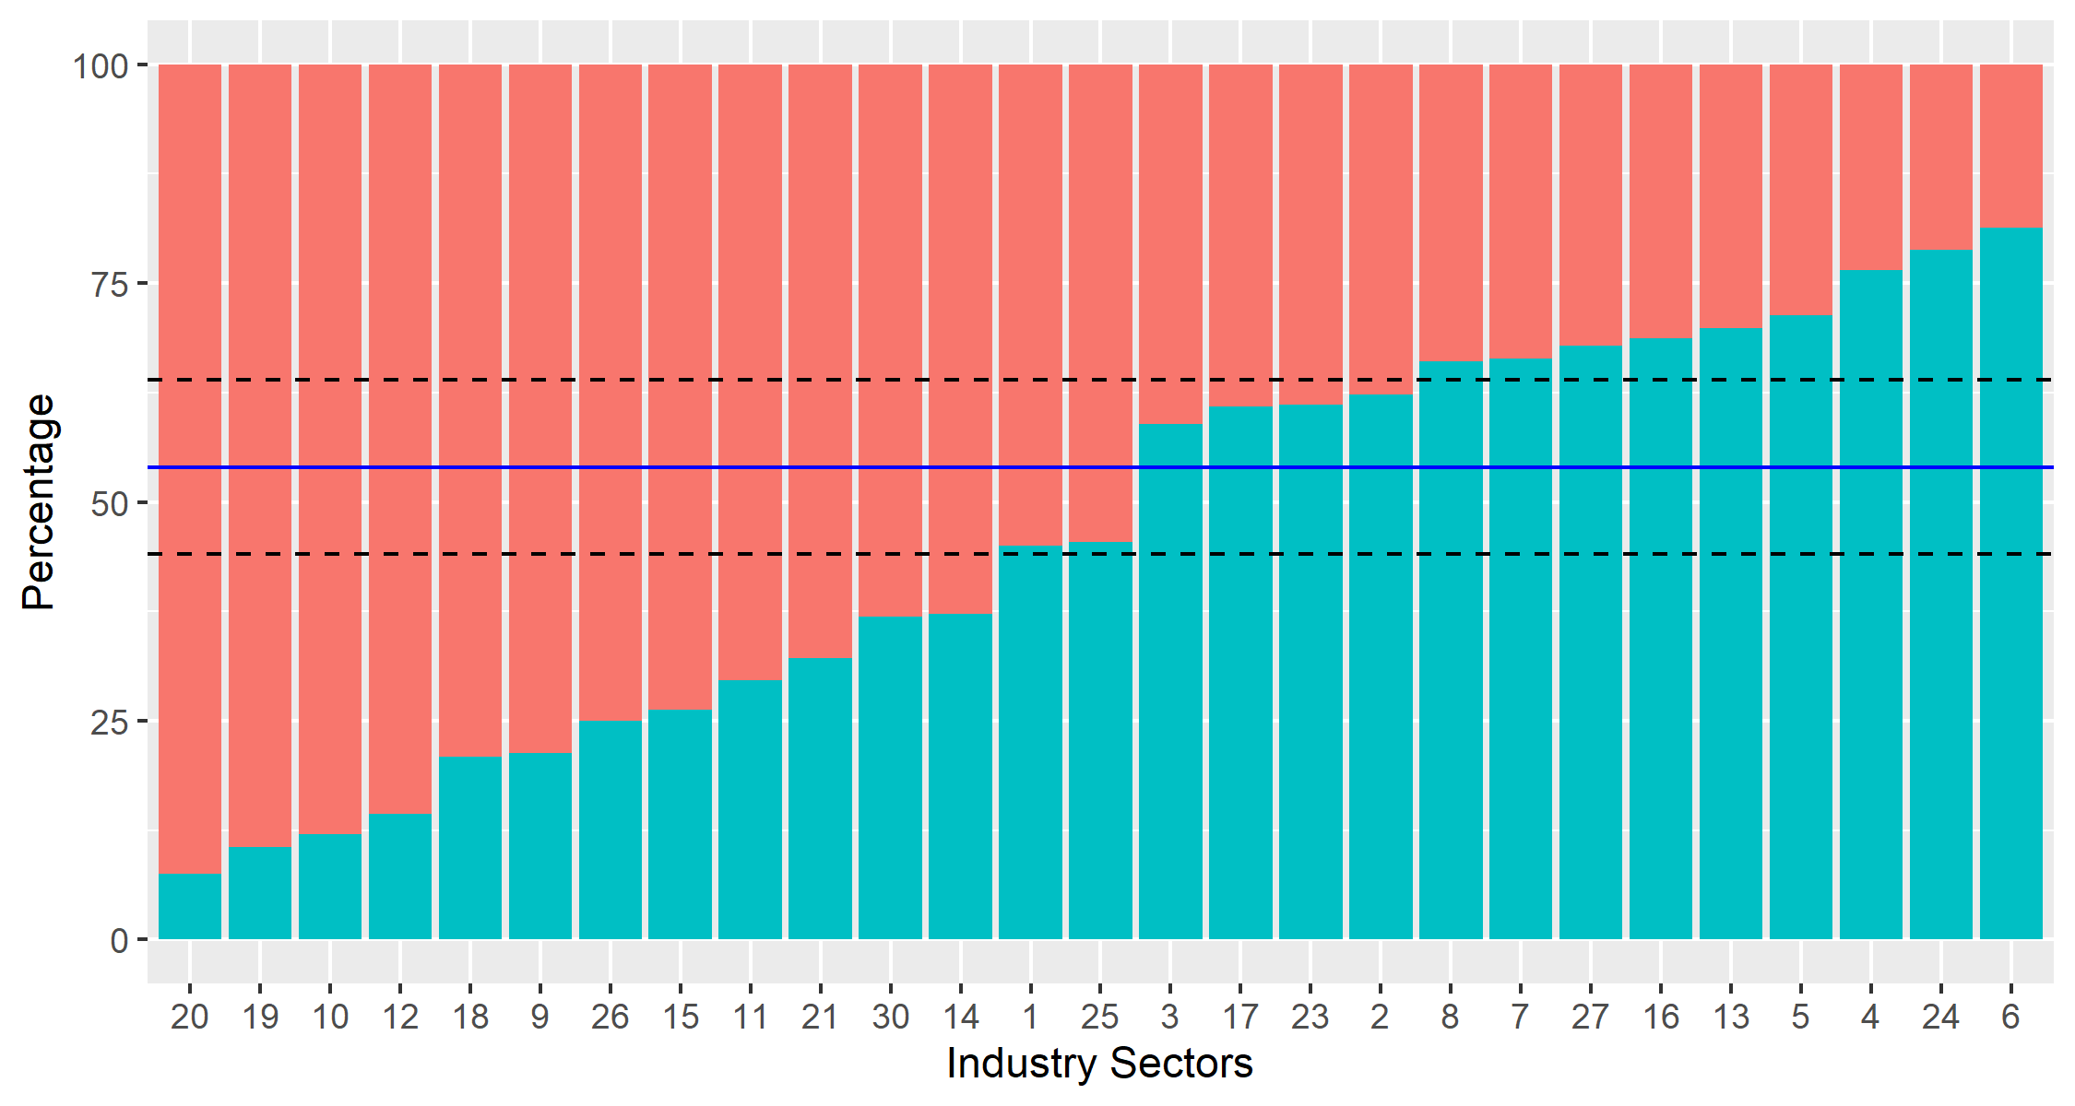

**FIGURE 2.1** Distribution of Employment in RLMS 2018 by Industry and Gender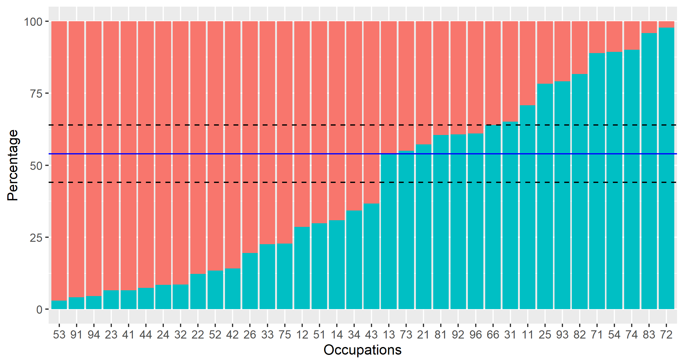

**FIGURE 2.2** Distribution of Employment in RLMS 2018 by Occupation and Gender

**TABLE 2.1** Industries by Strength of Female Proportion, RLMS 2018

| **Category** | **Sector** | **N fem** | **% fem** | **N total** |
| --- | --- | --- | --- | --- |
| Female  dominated | Social Services | 37 | 92.5% | 40 |
| Other | 17 | 89.5% | 19 |
| Education | 609 | 88.0% | 692 |
| Public Health | 412 | 85.7% | 481 |
| Real Estate Operations | 19 | 79.2% | 24 |
| Government and Public Administration | 155 | 78.7% | 197 |
| General Public Services | 15 | 75.0% | 20 |
| Finance | 107 | 73.8% | 145 |
| Science, Culture | 100 | 70.4% | 142 |
| Jurisprudence | 19 | 67.9% | 28 |
| Neutral | Mass Media, Telecommunications | 24 | 63.2% | 38 |
| Trade, Consumer Services | 738 | 62.8% | 1175 |
| Light industry, Food industry | 209 | 55.0% | 380 |
| Sports, Tourism, Entertainment | 18 | 54.5% | 33 |
| Male  dominated | Military Industrial Complex | 67 | 41.1% | 163 |
| Housing and Community Services | 95 | 39.1% | 243 |
| Chemical Industry | 14 | 38.9% | 36 |
| Civil Machine Construction | 51 | 37.8% | 135 |
| Agriculture | 79 | 33.9% | 233 |
| Transportation, Communication | 186 | 33.6% | 553 |
| Information Technology | 9 | 32.1% | 28 |
| Energy or Power Industry | 41 | 31.3% | 131 |
| Army, Internal Security | 90 | 30.1% | 299 |
| Other Heavy Industry | 60 | 28.7% | 209 |
| Oil and Gas Industry | 52 | 23.5% | 221 |
| Wood, Timber, Forestry | 7 | 21.2% | 33 |
| Construction | 73 | 18.7% | 391 |
| Total | 3303 | 54.3% | 6089 |

**TABLE 2.2** Occupations by Strength of Female Proportion, RLMS 2018

|  | **Occupation** | **N fem** | **% fem** | **N total** |
| --- | --- | --- | --- | --- |
| 1 | Personal Care Workers | 97 | 97.0% | 100 |
| 2 | Cleaners and Helpers | 163 | 95.9% | 170 |
| 3 | Food Preparation Assistants | 21 | 95.5% | 22 |
| 4 | Teaching Professionals | 370 | 93.4% | 396 |
| 5 | General and Keyboard Clerks | 71 | 93.4% | 76 |
| 6 | Other Clerical Support Workers | 25 | 92.6% | 27 |
| 7 | Business and Administration Professionals | 97 | 91.5% | 106 |
| 8 | Health Associate Professionals | 192 | 91.4% | 210 |
| 9 | Health Professionals | 79 | 87.8% | 90 |
| 10 | Sales Workers | 350 | 86.6% | 404 |
| 11 | Customer Services Clerks | 67 | 85.9% | 78 |
| 12 | Legal, Social and Cultural Professionals | 169 | 80.5% | 210 |
| 13 | Business and Administration Associate Professionals | 517 | 77.4% | 668 |
| 14 | Food Processing, Woodworking, Garment and Other Craft and Related Trades Workers | 51 | 77.3% | 66 |
| 15 | Administrative and Commercial Managers | 25 | 71.4% | 35 |
| 16 | Personal Services Workers | 172 | 70.5% | 244 |
| 17 | Hospitality, Retail and Other Services Managers | 38 | 69.1% | 55 |
| 18 | Legal, Social, Cultural and Related Associate Professionals | 69 | 65.7% | 105 |
| 19 | Numerical and Material Recording Clerks | 100 | 63.3% | 158 |
| 20 | Production and Specialized Services Managers | 139 | 46.0% | 302 |
| 21 | Handicraft and Printing Workers | 9 | 45.0% | 20 |
| 22 | Science and Engineering Professionals | 101 | 42.8% | 236 |
| 23 | Stationary Plant and Machine Operators | 72 | 39.6% | 182 |
| 24 | Agricultural, Forestry and Fishery Laborers | 11 | 39.3% | 28 |
| 25 | Refuse Workers and Other Elementary Workers | 30 | 39.0% | 77 |
| 26 | Miscellaneous non-ISCO | 9 | 36.0% | 25 |
| 27 | Science and Engineering Associate Professionals | 120 | 34.9% | 344 |
| 28 | Chief Executives, Senior Officials and Legislators | 7 | 29.2% | 24 |
| 29 | Information and Communications Technology Professionals | 15 | 21.7% | 69 |
| 30 | Laborers in Mining, Construction, Manufacturing and Transport | 24 | 20.9% | 115 |
| 31 | Assemblers | 11 | 18.3% | 60 |
| 32 | Building and Related Trades Workers (excluding Electricians) | 23 | 11.1% | 207 |
| 33 | Protective Services Workers | 23 | 10.7% | 215 |
| 34 | Electrical and Electronic Trades Workers | 16 | 9.9% | 162 |
| 35 | Drivers and Mobile Plant Operators | 23 | 4.1% | 558 |
| 36 | Metal, Machinery and Related Trades Workers | 6 | 2.2% | 267 |

**Adaptation of Neuman and Weiss**

The Neuman and Weiss model provides an estimation of the depreciation rate for human capital, but by itself is unable to identify how much of that depreciation is external or internal. External depreciation is due to obsolescence (as new technologies make skills redundant) and internal depreciation is due to factors related to the individual. Neuman and Weiss had access in their empirical application to data about the technology level of the Israeli firms to which the workers belonged. They were able to show the differential effect on depreciation of workers in ‘high-tech firms’, thus providing evidence in support of their model. If depreciation is greater for the workers in high technology industries, the amount by which depreciation is greater for such workers can be attributed to obsolescence, which is what they find. In the present paper, we do not have access to data about the technology level of firms, but we are able to exploit two variations that also help us to understand better the depreciation phenomenon: gender segregation is the first one of these two variations. Examining differences in depreciation rate by the gender segregation classification helps us to identify internal and external depreciation based on a conjecture. The conjecture is that external depreciation would have a greater affect by industry sector, as technological change would propagate more rapidly through a sector rather than through occupations, which are dispersed across sectors.

Table 2.3 depicts average rates of human capital loss due to experience and education by the female- and male-dominated industrial sectors and occupations. Industry or sector related differences does show difference in the depreciation rate, with depreciation rate being higher for male dominated industrial sectors. These are engineering and technology-oriented sectors, compared to administration, services, and education which are the female dominated sectors. The depreciation does not appear to vary across occupational groupings - male dominated and female dominated occupation groupings have similar depreciation rates. These findings need to be treated as preliminary findings as they are only point estimates of depreciation, evaluated at mean values.

A second adaptation of the Neuman and Weiss approach is to consider data on occupational routineness. In the next sub-section, we follow a research path that was first laid out by Acemoglu and Autor (2011) to understand the impact of automation on the labor market. Following the Neuman and Weiss logic, the prior hypothesis would be that obsolescence will have higher effect on jobs with more routine tasks. To the extent that there is less of a difference in depreciation according to routineness measures, we can infer that there is less effect of obsolescence and more effect of intrinsic depreciation; or that obsolescence of human capital is less related to routineness and threat of automation.

**TABLE 2.3** Average Human Capital Depreciation Rates (DR) by   
Female- and Male-dominated Industries and Occupations, RLMS 2018

|  |  |  |  |  |
| --- | --- | --- | --- | --- |
| **Statistic** | **Ind_F** | **Ind_M** | **occfemale** | **occmale** |
| Experience, mean | 23.45 | 22.97 | 21.67 | 23.48 |
| Education, mean | 14.06 | 13.01 | 13.67 | 12.67 |
| DR Experience, % | 0.89 | 1.82 | 1.55 | 1.40 |
| DR Education, % | 0.00 | 0.00 | 0.00 | 0.00 |
| DR Human Capital, % | 0.89 | 1.82 | 1.55 | 1.40 |

## Depreciation and Occupational Routineness

In addition to the examination of human capital depreciation rates in gender-dominated industries and occupations, we explore differences in depreciation between groups generated by using an array of routine and non-routine task content metrics for jobs. This is important in light of discussion about computers and robots taking over routine oriented jobs. In this analysis, we rely on a recent literature of job classification based on task intensity measures (Mihaylov and Tijdens 2019). These measures are based on the textual analysis of description of jobs in the ISCO 08 classification. Each job lists a detailed set of activities or tasks performed as part of the job, and these activities are rated according to whether they are vulnerable to automation in which case they are classified as Routine (R), otherwise they are Non-Routine (NR). Tasks are also classified depending on their Cognitive (C) or Manual (M) requirements; Cognitive tasks are further classified as mainly Analytic (A) or Interactive (I). The results are a five-fold classification of tasks, which is subsequently used to develop a set of measures depending on the incidence of these tasks in the job description.

For purpose of this analysis, we use two of these measures. Routine Task Intensity measure (RTI) denotes a score difference between the summed routine task indices and the summed non-routine task indices: - it is a net measure of job routineness or vulnerability to automation. We also use a gross measure that brings together the non-routine task indices: . Using the k-means clustering technique for the metrics described, we created two respective categorical variables (drti and dnraim) with categories capturing *high, medium,* and *low* manifestations of the features.

Table 2.4 shows the results of comparing depreciation rates between individuals whose jobs invoke routine or non-routine tasks at a high, medium, or low level. The findings suggest that depreciation explained by experience does not differ substantially between people with jobs with varying routine task intensity. The same outcome also applies to workers varying in the degree of non-routine content at their jobs. As with the findings regarding gender, these should be regarded as preliminary findings subject to further analysis. However, it does appear that the automation aspect of technological change may not be affecting the rate of depreciation of skills - both routine and non-routine intensive jobs undergo depreciation, though it is possibly that the underlying causal factors may be different.

**TABLE 2.4** Average Human Capital Depreciation Rates (DR) by Routineness Classification, RLMS 2018

|  |  |  |  |  |  |  |
| --- | --- | --- | --- | --- | --- | --- |
| **Statistic** | **High** | **Low** | **Medium** | **High** | **Low** | **Medium** |
| Measure | drti | drti | drti | dnraim | dnraim | dnraim |
| Experience, mean | 21.44 | 22.79 | 22.76 | 22.94 | 22.22 | 22.05 |
| Education, mean | 12.86 | 13.67 | 12.8 | 13.66 | 12.76 | 13.02 |
| DR Experience, % | 1.8 | 1.5 | 1.64 | 1.62 | 1.73 | 1.48 |
| DR Education, % | 0 | 0 | 0 | 0 | 0 | 0 |
| DR Human Capital, % | 1.8 | 1.5 | 1.64 | 1.62 | 1.73 | 1.48 |

# Summarized Findings and Policy Conclusions

## Summarized Findings

This paper has covered substantive technical material. The main findings are summarized in the points below:

* **Depreciation of 2%** The topic of depreciation of human capital is important from the policy perspective because increasing the human capital can be made both by the creation of human capital as well as reducing the depreciation of human capital to the extent possible. In this paper per first presented an overview of the literature regarding depreciation of human capital and present estimates of depreciation in the Russian Federation. Depreciation appears to be around 2% per year in the most recent finding, with the depreciation mostly attributed to depreciation of human capital acquired with experience (Table 1.2).
* **Depreciation declining then increasing** The pattern of the depreciation rate indicates a gentle decline followed by an increase in the period 1994-2018 (Table 1.2 and Table 1.3). This pattern is a reflection of the inverted-U shaped pattern of the rates of return to education. It is possible that depreciation may be an explanation for the observed tendency in the returns to education.
* **University educated individuals make more post-school investment too** In estimating rates of depreciation, we undertake an exploration of a related parameter that represents post-schooling investment in human capital. The data indicates that post-schooling investment for those with vocational education is indistinguishable from those with only secondary education. However, those with university education appear to be investing more in their working period (Table 1.4).
* **Males may be experiencing higher depreciation than females** The paper explored differences in depreciation rates across industrial and occupation groupings denoted by levels of gender segregation Depreciation rates appear to be higher in male dominated industrial sectors, but gender related occupational groupings do not show this differential. The evidence suggests that external depreciation due to obsolescence may be a dominant component of the depreciation of human capital (Table 2.3).
* **Automation possibilities of jobs may not be related to depreciation** The paper used a relatively recent classification of jobs regarding the potential for automation depending on the routine or non-routine nature of tasks. It was hypothesized that routine intensive jobs which are more likely to be taken over by computers may suffer from a higher depreciation rate, but the data do not reveal differences in depreciation rate by routine task intensity (Table 2.4).

## Policy Conclusions

These findings and the context of the larger literature on depreciation and the returns to education results in the following policy conclusions:

* **Emphasize lifelong learning to augment human capital wealth** Non-cognitive skills that are formed throughout the lifetime have equally strong effects on productivity (Kautz et al. 2014). Research in Norway backs up this claim (Midtsundstad and Nielsen 2019). Investment in lifelong learning will be more relevant for the Russian Federation as the average age of retirement moves out (Kilpi-Jakonen et al. 2012; Paccagnella 2016).
* **Renovate curriculum and stress extra-curricular education at all levels to emphasize learning to learn** Enhanced lifelong learning capacity begins at an early age (Kautz et al. 2014). Curriculum from early grades to university will benefit from greater emphasis on application of critical thinking and problem-solving skills. Extra-curricular education is geared towards non-cognitive skills and the Russian Federation is already a world leader in this area.
* **Support internal migration which brings better efficiency and equity to the labor market** The Russian Federation benefits from substantive internal migration and migration from the former Soviet republics that are now independent (Tarasyev and Jabbar 2018). Policies should support this migration by easing restrictions on worker movements (Oshchepkov 2015).
* **Investigate more closely the determinants and the impact of depreciation of human capital in the Russian context** There are a number of areas where further inquiry will provide useful insights. In addition to the areas already mentioned above of migration, curriculum and life-long learning programs, the following research areas are promising: (i) How returns to education over the lifetime vary for STEM disciplines (Deming and Noray 2018); (ii) How digitization of jobs in relation to automation may or may be related to the findings regarding routineness (Cirillo et al. 2019; Evangelista, Guerrieri, and Meliciani 2014); (iii) How is aging related to changes in productivity and what are effective programs to counter the effect of aging, such as deployment of specific equipment and infrastructure for older people and the formation of mixed-age work teams (Göbel and Zwick 2009, 2013).

# References

Acemoglu, Daron, and David Autor. 2011. “Skills, Tasks and Technologies: Implications for Employment and Earnings.” Pp. 1043–1171 in *Handbook of labor economics*. Vol. 4. Elsevier.

Arrazola, María, José de Hevia, Marta Risueño, and Jose Felix Sanz. 2005. “A Proposal to Estimate Human Capital Depreciation: Some Evidence for Spain.” *Hacienda Publica Espanola–Revista de Economia Publica* 172(1):9–22.

Blau, Francine D., Peter Brummund, and Albert Yung-Hsu Liu. 2013. “Trends in Occupational Segregation by Gender 1970–2009: Adjusting for the Impact of Changes in the Occupational Coding System.” *Demography* 50(2):471–92.

Cirillo, Valeria, Rinaldo Evangelista, Dario Guarascio, and Matteo Sostero. 2019. “Digitalization, Routineness and Employment: An Exploration on Italian Task-Based Data.”

Deming, David J., and Kadeem L. Noray. 2018. *Stem Careers and the Changing Skill Requirements of Work*. National Bureau of Economic Research.

Evangelista, Rinaldo, Paolo Guerrieri, and Valentina Meliciani. 2014. “The Economic Impact of Digital Technologies in Europe.” *Economics of Innovation and New Technology* 23(8):802–824.

Göbel, Christian, and Thomas Zwick. 2009. “Age and Productivity-Evidence from Linked Employer Employee Data.” *ZEW-Centre for European Economic Research Discussion Paper* (09–020).

Göbel, Christian, and Thomas Zwick. 2013. “Are Personnel Measures Effective in Increasing Productivity of Old Workers?” *Labour Economics* 22:80–93.

Kautz, Tim, James J. Heckman, Ron Diris, Bas Ter Weel, and Lex Borghans. 2014. *Fostering and Measuring Skills: Improving Cognitive and Non-Cognitive Skills to Promote Lifetime Success*. National Bureau of Economic Research.

Kilpi-Jakonen, Elina, Daniela Vono de Vilhena, Yuliya Kosyakova, Anders Stenberg, and Hans-Peter Blossfeld. 2012. “The Impact of Formal Adult Education on the Likelihood of Being Employed: A Comparative Overview.” *Studies of Transition States and Societies* 4(1).

Klimova, Anastasia. 2009. “159. Gender Occupational Segregation in the Russian Labour Market.” *University of Technology, Sydney Working Paper*.

Klimova, Anastasia, and Russell Ross. 2012. “Gender-Based Occupational Segregation in Russia: An Empirical Study.” *International Journal of Social Economics* 39(7):474–89.

Kosyakova, Yuliya, Dmitry Kurakin, and Hans-Peter Blossfeld. 2015. “Horizontal and Vertical Gender Segregation in Russia—Changes upon Labour Market Entry before and after the Collapse of the Soviet Regime.” *European Sociological Review* 31(5):573–90.

Midtsundstad, Tove, and Roy A. Nielsen. 2019. “Lifelong Learning and the Continued Participation of Older Norwegian Adults in Employment.” *European Journal of Education* 54(1):48–59.

Mihaylov, Emil, and Kea Gartje Tijdens. 2019. “Measuring the Routine and Non-Routine Task Content of 427 Four-Digit ISCO-08 Occupations.” *Tinbergen Institute Discussion Paper* TI 2019-035/V.

Mincer, Jacob, and Haim Ofek. 1982. “Interrupted Work Careers: Depreciation and Restoration of Human Capital.” *Journal of Human Resources* 3–24.

Murillo, Ines P. 2006. “Returns to Education and Human Capital Depreciation in Spain.” *Econstor Working Paper*.

Neuman, Shoshana, and Avi Weiss. 1995. “On the Effects of Schooling Vintage on Experience-Earnings Profiles: Theory and Evidence.” *European Economic Review* 39(5):943–55.

Oshchepkov, Aleksey. 2015. “Compensating Wage Differentials across Russian Regions.” Pp. 65–105 in *Geographical Labor Market Imbalances*. Springer.

Paccagnella, Marco. 2016. “Age, Ageing and Skills.”

Patrinos, Harry, Suhas Parandekar, Ekaterina Melianova, and Artem Volgin. 2020. “WP 1 - Returns to Education in the Russian Federation: Some New Estimates.” *World Bank ASA P170979 Russian Federation*.

Preston, Jo Anne. 1999. “Occupational Gender Segregation Trends and Explanations.” *The Quarterly Review of Economics and Finance* 39(5):611–24.

Rosen, Sherwin. 1976. “A Theory of Life Earnings.” *Journal of Political Economy* 84(4, Part 2):S45–67.

Tarasyev, Alexandr A., and Jeenat B. Jabbar. 2018. “Dynamic Modeling of Labor Migration Impact on the Economic System Development.” *IFAC-PapersOnLine* 51(32):407–412.

Weber, Sylvain. 2008. “Human Capital Depreciation and Education Level: Some Evidence for Switzerland.” Amsterdam, The Nnetherlands.

Weber, Sylvain. 2011. “156. On the Impact of Education on Human Capital Depreciation, Wage Growth, and Tenure.” University of Geneva.

# Appendix

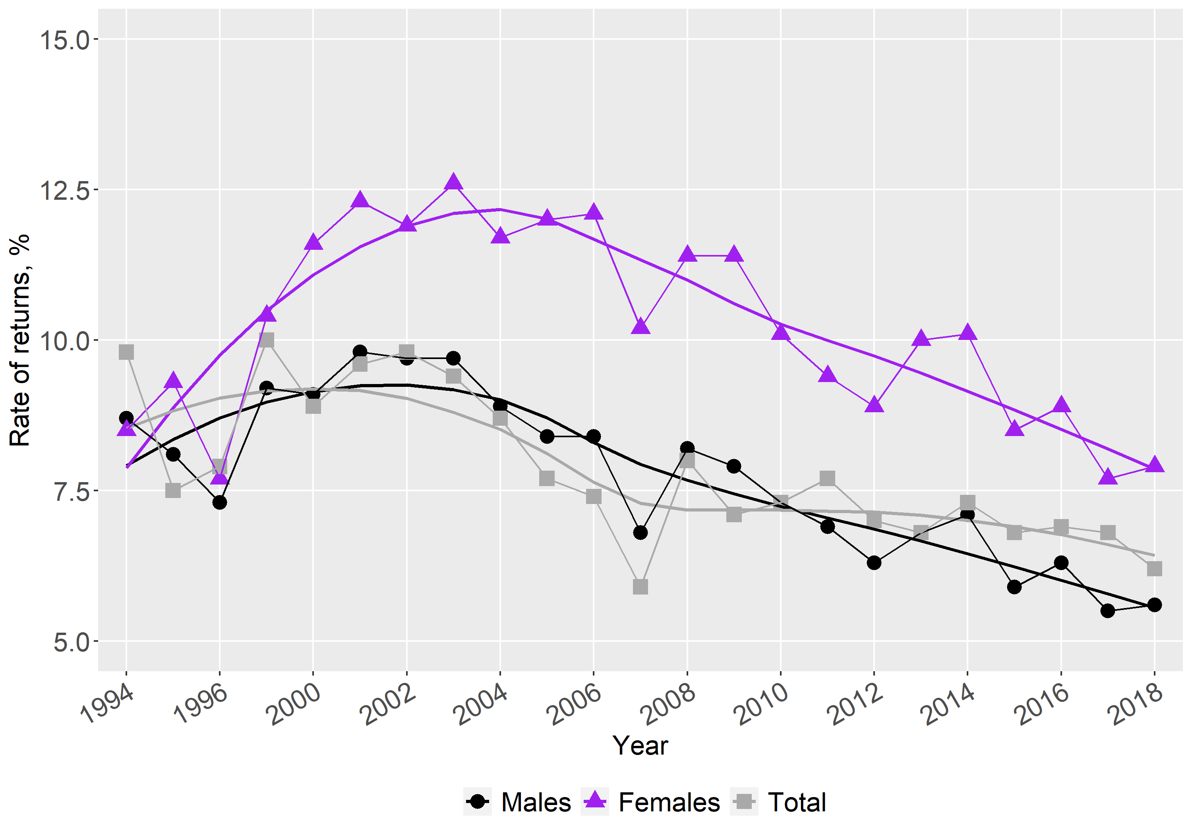

**FIGURE A1**. Mincerian Rates of Return to Education in Russia 1994 to 2018